Copyright for test papers and marking guides remains with *West Australian Test Papers*.

The papers may only be reproduced within the purchasing school according to the advertised conditions of sale.

Test papers must be withdrawn after use and stored securely in the school until Friday June 15

# Marking Key

**HUMAN BIOLOGY**

**Unit 1**

**2018**

Name: _______________________________________________________

Teacher: ___________________________________________________

**Time allowed for this paper**

Reading time before commencing work: Ten minutes

Working time for the paper: Three Hours

**Materials required/recommended for this paper**

***To be provided by the supervisor***

* This Question/Answer Booklet
* Multiple Choice Answer Sheet

***To be provided by the candidate***

* Standard items: pens (blue/black preferred), pencils (including coloured), sharpener,

correction fluid/tape, eraser, ruler, highlighters

* Special items: non-programmable calculators approved for use in this examination

**Important note to candidates**

No other items may be taken into the examination room. It is **your** responsibility to ensure that you do not have any unauthorised material. If you have any unauthorised material with you, hand it to the supervisor **before** reading any further.

**Structure of this paper**

|  |  |  |  |  |  |
| --- | --- | --- | --- | --- | --- |
| Section | Number of questions available | Number of questions to be answered | Suggested working time (minutes) | Marks | Percentage of examination |
| Section One  Multiple-choice | 25 | 25 | 30 | 25 | 30 |
| Section Two  Short answer | 9 | 9 | 80 | 85 | 50 |
| Section Three  Extended answer | 3 | 2 | 40 | 30 | 20 |
| **Total** | | | | | 100 |

**Instructions to candidates**

1. The rules for the conduct of Western Australian external examinations are detailed in the *Year 12 Information Handbook 2018.* Sitting this examination implies that you agree to abide by these rules.

2. Answer the questions according to the following instructions.

Section One: Answer all questions on the separate Multiple-choice Answer Sheet provided. For each question, shade the box to indicate your answer. Use only a blue or black pen to shade the boxes. If you make a mistake, place a cross through that square, then shade your new answer. Do not erase or use correction fluid/tape. Marks will not be deducted for incorrect answers. No marks will be given if more than one answer is completed for any question.

Sections Two: Write your answers in this Question/Answer Booklet. Wherever possible, confine your answers to the line spaces provided.

Section Three: Consists of three questions. You must answer two questions. Tick the box next to the question you are answering. Write your answers in this Question/Answer booklet.

3. You must be careful to confine your responses to the specific questions asked and to follow any instructions that are specific to a particular question.

4. Supplementary pages for the use of planning/continuing your answer to a question have been provided at the end of this Question/Answer booklet. If you use these pages to continue an answer, indicate at the original answer where the answer is continued, i.e. give the page number.

**Section One: Multiple-choice 30% (25 Marks)**

**_______________________________________________________________________________**

|  |  |
| --- | --- |
| **Question** | **Answer** |
| 1 | a |
| 2 | c |
| 3 | b |
| 4 | a |
| 5 | c |
| 6 | d |
| 7 | a |
| 8 | a |
| 9 | c |
| 10 | a |
| 11 | d |
| 12 | a |
| 13 | d |
| 14 | b |
| 15 | d |
| 16 | b |
| 17 | c |
| 18 | a |
| 19 | d |
| 20 | b |
| 21 | b |
| 22 | d |
| 23 | c |
| 24 | d |
| 25 | a |

**Section Two: Short answer 50% (85 Marks)**

_______________________________________________________________________________

**Question 26 (5 marks)**

The following question refers to the diagram of the plasma membrane as shown.

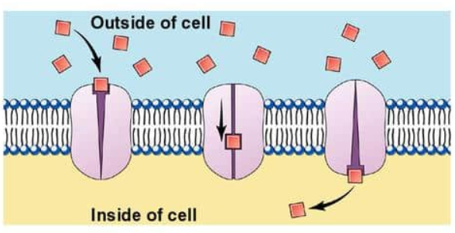

**Figure 1 Plasma membrane**

1. Identify the type of membrane transport shown in the diagram above. (1 mark)

|  |  |
| --- | --- |
| **Description** | **Mark** |
| Diffusion - carrier-mediated transport / passive carrier-mediated transport (1/2 mark if only diffusion) | 1 |
| **Total** | **1** |

1. Name **one** substance that is transported using this type of membrane transport identified in part (a). (1 mark)

|  |  |
| --- | --- |
| **Description** | **Mark** |
| glucose / amino acid / fructose / galactose / nucleosides etc. | 1 |
| **Total** | **1** |

1. State a location in the human body this mode of membrane transport likely to take place.

(1 mark)

|  |  |
| --- | --- |
| **Description** | **Mark** |
| Red blood cells Muscle cells / cells of the liver/ epithelial cells of the small intestine / general body cells for transport of the above | 1 |
| **Total** | **1** |

1. State **two** characteristics of carrier-mediated transport in the cell membrane. (2 marks)

|  |  |
| --- | --- |
| **Description** | **Mark** |
| Any two of the following: |  |
| Specific / can only bind to a particular molecule / can become saturated / once all carriers are occupied, increased concentration cannot increase rate of movement/ regulated by hormones / hormones co-ordinate the activities of carrier proteins | 1 - 2 |
| **Total** | **2** |

**Question 27** (12 marks)

1. Using a fully annotated diagram in the space below, demonstrate the lock and key model of enzyme reaction. (4 marks)

|  |  |
| --- | --- |
| **Description** | **Mark** |
| Diagram given below as an example:    1 mark for drawing enzyme and substrate  1 mark for drawing enzyme substrate complex  1 mark for daring enzyme and products | |
| 1 mark for labelling all the listed features ie. enzyme, substrate, enzyme – substrate complex, and products. | |
| **Total** | **4** |

1. Why is an enzyme described as being “substrate specific”? (1 mark)

|  |  |
| --- | --- |
| **Description** | **Mark** |
| Only the correct substrate has the right shape to fit into the enzyme’s active site/ complementary shape of substrate to active site (must refer to shape of active site) (i/2 mark for similar pattern or shape but not referring to active site) | 1 |
| **Total** | **1** |

1. How does an enzyme act as a catalyst for reactions? (1 mark)

|  |  |
| --- | --- |
| **Description** | **Mark** |
| Lowers the activation energy | 1 |
| **Total** | **1** |

Enzymes are necessary for chemical reactions to occur at a rate that can

support biological life. The following graph shows the initial rate of reaction of the enzyme

fluoroacetate dehalogenase (FAcD) as it converts substrate into products, glycolate and a

halogen, as substrate concentration is increased over a period of an hour.

**Initial rate of reaction with increasing substrate concentration**

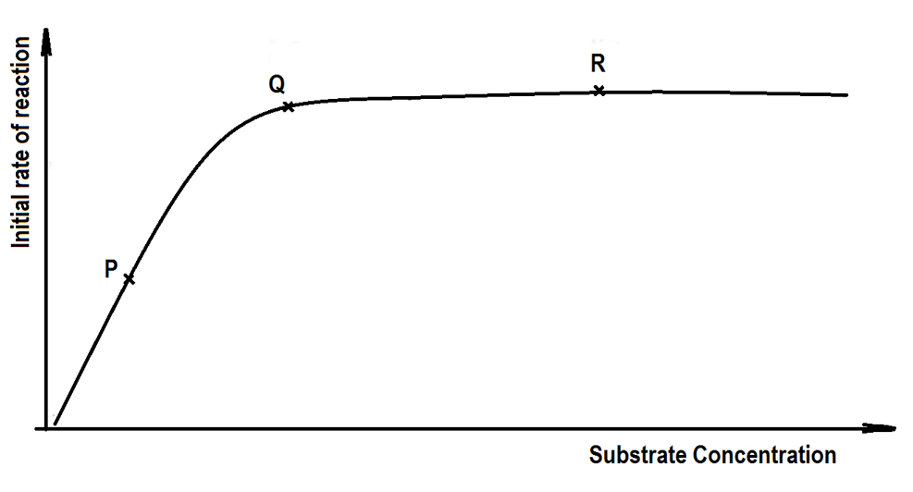

**Figure 3**

1. Using the terms `**active site’, `rate of reaction’, `substrate’ and `enzyme’ molecules**, explain what has happened at point P, Q and R. (6 marks)

|  |  |  |
| --- | --- | --- |
| **Description** | | **Mark** |
| (i) | At P, when the **substrate** concentration is low, the **rate of reaction** is half of the maximum possible for the number of **enzyme** molecules available.  Reason: Too few substrate molecules available to occupy all available **active sites**. | 1 - 2 |
| (ii) | At Q, when the **substrate** concentration is moderate/ intermediate, the **rate of reaction** by the **enzymes** is doubled to its maximum.  Reason: With twice as many **substrate** molecules, all **active sites** are fully occupied. | 1 - 2 |
| (iii) | At R, when the **substrate** concentration is high, there is no increase in **rate of reaction** by the **enzymes**.  Reason: Addition of **substrate** has no effect as all **actives sites** are occupied. | 1 - 2 |
| **Total** | | **6** |

**Question 28 (10 marks)**

1. Draw an annotated diagram of the sliding filament model and explain how muscle contraction takes place using this model.

(5 marks)

|  |  |
| --- | --- |
| **Description** | **Mark** |
| 1 mark for diagram and 1 for labels | 2 |
|  |  |
| * As the muscle contracts the actin and myosin filaments slide past each other. * the sarcomere shortens * and the Z lines move closer to one another. * (or similar)   (When the muscle relaxes, the actin and myosin filaments are pulled past one another in the opposite direction and the sarcomere lengthens.) | 1 - 3 |
| **Total** | **5** |

1. Name and describe a muscular or a skeletal condition that occurs due to ageing. (2 marks)

|  |  |
| --- | --- |
| **Description** | **Mark** |
| Any one of the following: |  |
| Sarcopenia - A degenerative loss of skeletal muscle | 1 -2 |
| Osteoarthritis - Pain and stiffness of joints due to the deterioration of the joint cartilage, wearing away of the exposed bone and formation of spurs. | 1 - 2 |
| Osteoporosis – loss of bone mass leading to decreased bone density and susceptibility to fractures. | 1 - 2 |
| **Total** | **2** |

1. State **one** common treatment used to prevent the onset of this named condition in the question above (c).

(1 mark)

|  |  |
| --- | --- |
| **Description** | **Mark** |
| Any one of the following for 1 mark each: |  |
| * Sarcopenia – exercise / physiotherapy  * Osteoarthritis – medication (analgesics / NSAIDS / narcotics) / physiotherapy to strengthen muscles around affected joints / surgery to re-align bones or joint replacement surgery  * Osteoporosis – adequate - calcium / vitamin D / exercise | 1 |
| **Total** | **1** |

Please read the following paragraph carefully to answer question (e).

**Use of Personal Devices in Diagnosis and Treatment**

The rise of increasingly sophisticated personal devices such as the iPhones and Fitbits means scientists can access information across all aspects of our daily lives. This information provided to scientists will give us better insight than ever before into how and when we get sick. At the forefront of this research is the Centre for Big Data Research in Health (CBDRH), at Australia’s University of New South Wales. This research centre is using an array of personal devices to find new ways of diagnosing and treating health diseases. “Smartphones now come with very sensitive accelerometers that can pick up the slightest tap or jiggle, so they are good devices to measure any type of body movement,” says Dr Timothy Churches, a data scientist at CBDRH and the Ingham Institute in Sydney. Australian scientists are currently looking at using smartphones to characterise the gaits of patients after surgery, and using machine learning methods to try and detect changes that could occur in patients suffering from musculo-skeletal dysfunctions.

Adapted from Cosmos Magazine 9 Oct 2017

1. Comment on how the use of smartphones can be used to improve practices for the management and prevention of the condition identified in parts (c) and (d). (2 marks)

|  |  |
| --- | --- |
| **Description** | **Mark** |
| Any two of the following: |  |
| Provide / can access more information/ leads to an increased understanding or better understanding  greater sensitivity to motor movements means pain control can be better regulated / appropriate type of pain control medications can be given  increased range/ appropriate type of weight-bearing and muscle-strengthening exercise  regulate anti-fracture therapies that include medications that improve bone quality | 1 - 2 |

**Question 29 (5 marks)**

1. Name the location in the cell where each of these processes below occur. (3 marks)

|  |  |
| --- | --- |
| **Process** | **Location in the cell** |
| Glycolysis | cytoplasm |
| Krebs Cycle  (citric acid cycle) | mitochondria |
| Electron transport chain | mitochondrion cristae/inner membrane surface (accept mitochondria) |
| One mark for each correct location | |
| **Total** | **3** |

1. Explain why the mitochondria are described as the `power house’ of the cell. (2 marks)

|  |  |
| --- | --- |
| **Description** | **Mark** |
| 1 mark each (or anything else relevant) |  |
| The reactions of the **aerobic** respiration take place in the mitochondria.  Aerobic respiration produces majority of the ATP.  (breaking down glucose not acceptable) | 1 - 2 |
| Total | 2 |

**Question 30 (8 marks)**

The following question refer to the diagram of the human digestive system shown below.

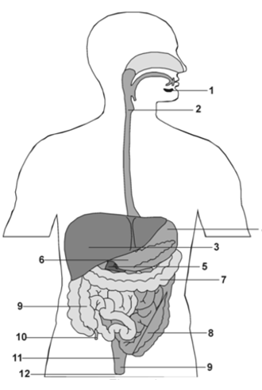

**Figure 4 Human Digestive System**

1. A slide has been taken from the longitudinal section of the tissue located in position **2,** showing the mucosa and muscle layers of this tissue.

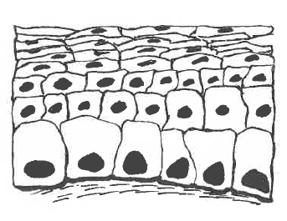

**Figure 5 Longitudinal section of tissue**

1. Identify the type of cell in Figure 5 and state a function of these cells. (2 marks)

|  |  |
| --- | --- |
| **Description** | **Mark** |
| Epithelial cells | 1 |
| These cells secrete mucus  (also accept lining or smooth surface – these are also function) | 1 |
| **Total** | **2** |

The diagram below show the muscle layers that are located also at location 2.

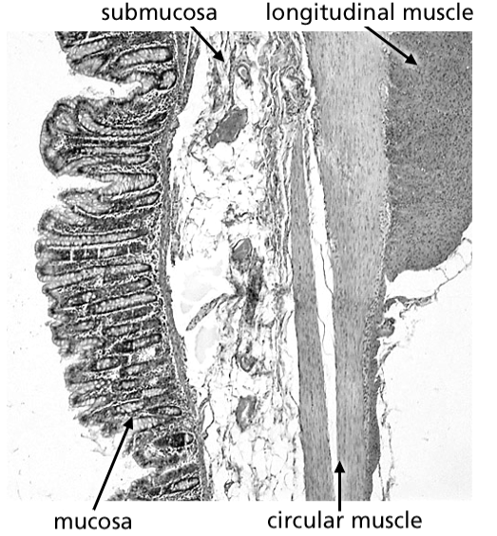

**Figure 6 Muscular tissue**

1. As shown above, the muscle is arranged into both circular and longitudinal directions. State why this muscle arrangement is necessary at location 2. (1 mark)

|  |  |
| --- | --- |
| **Description** | **Mark** |
| It allows for peristaltic movement/ peristalsis / produces a direction for movement of food | 1 |
| **Total** | **1** |

1. State **two** other numbered locations from Figure 4: Human Digestive System that would share the same function as this muscle arrangement. (1 mark)

|  |  |
| --- | --- |
| **Description** | **Mark** |
| Any two of the four locations given to obtain 1 mark. |  |
| 4,7,8,9 (stomach, large intestine [transverse colon], small intestine, large intestine [(ascending colon] | 1 |
| **Total** | **1** |

1. State **two** structural similarities and **one** difference between locations 2 and 8. (3 marks)

|  |  |
| --- | --- |
| **Description** | **Mark** |
| Similarities |  |
| Both oesophagus (no.2) and ileum (no.8) are parts of one long tube. | 1 |
| Both are surrounded by layers of muscles for peristalsis. | 1 |
| Difference – any one of the following: |  |
| the inner wall of the **ileum (no.8)** is folded into villi, which greatly increase its surface area /  size of the lumen of that section; the small intestine can be divided into three sections  (needs to be structural not functional difference or similarity) | 1 |
| **Total** | **3** |

1. Unlike the rest of the alimentary canal, the stomach has an oblique muscle layer in addition. State how this facilitates its function. (1 mark)

|  |  |
| --- | --- |
| **Description** | **Mark** |
| enable the stomach to contract in a variety of ways to churn | 1 |
| **Total** | **1** |

**Question 31 (9 marks)**

The heart is a muscular organ that lies in the thoracic cavity behind the sternum. It has four chambers and these are connected to large blood vessels that carry blood towards and away from the heart.

1. Name the blood vessel associated with the heart that matches the appropriate description in the table below. (4 marks)

|  |  |
| --- | --- |
| **Description** | **Blood vessel** |
| It supplies the heart muscle with oxygenated blood | coronary artery |
| It has the highest blood pressure | aorta |
| It carries oxygenated blood to the heart | pulmonary vein |
| It joins the ventricles of the heart to the capillaries of the lungs | pulmonary artery |
| **Total** | **4** |

1. Explain why is it important to prevent mixing of the blood in the two sides of the heart.

(2 marks)

|  |  |
| --- | --- |
| **Description** | **Mark** |
| partially oxygenated blood would reach the tissues and the lungs | 1 |
| oxygen supply to the tissues would be inadequate/ reduced diffusion gradient in the lungs / rate of oxygen uptake is lessened | 1 |
| **Total** | **2** |

Question 31(c) refers to the graph below shows some features of the blood flow from and to the heart through a variety of blood vessels.

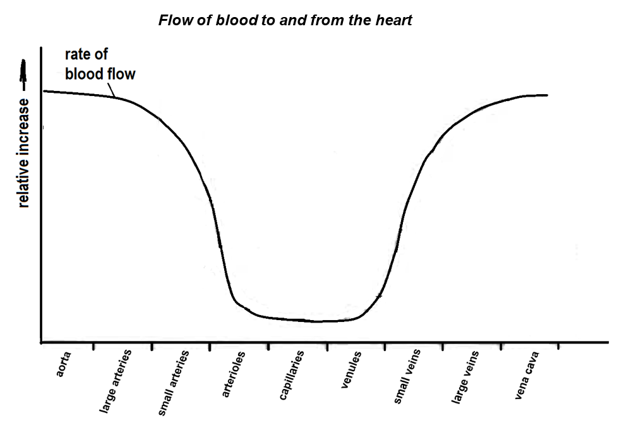

Figure 7

1. Describe **three** changes in the rate of blood flow as blood passes from the aorta to the vena cava. (3 marks)

|  |  |
| --- | --- |
| **Description** | **Mark** |
| Rate of blood flow decreases gradually in the aorta and large arteries and/or rapidly in small arteries | 1 |
| It remains relatively constant in the arterioles and the capillaries before increasing. | 1 |
| It flows at in increasing rate, in the venules and veins and vena cava.  (need to refer to **RATE** of blood flow not blood flow) | 1 |
| **Total** | **3** |

**Question 32 (16 marks)**

There are a number of factors that separately increase the risk of an individual suffering from cardiovascular disease. When combined together, the overall risk can be greatly amplified. An investigation was conducted to show the effect of three risk factors; namely, smoking, high blood pressure and blood cholesterol on the chance of heart attack in Australian men.

Category A refers to men who are heavy smokers and have high blood pressure.

Category B refers to men who are non-smokers and have high blood pressure.

Category C refers to men who are heavy smokers and have low blood pressure.

Category D refers to men who are non-smokers and have low blood pressure.

Data was collected from these four categories of men from a sample size of 1200 men. The percentage of these men suffering from heart attack in a 5-year-period had a range of blood cholesterol level varying from 5 mmol/L to 8 mmol/L. This information was recorded by a team of medical researchers at the University of Western Australia and the Royal Perth Hospital.

|  |  |  |  |  |
| --- | --- | --- | --- | --- |
| Blood cholesterol level  (mmol/L) | Percentage of men suffering from heart attack (%) | | | |
| Category A | Category B | Category C | Category D |
| 5.0 | 9 | 5 | 4 | 3 |
| 6.0 | 12 | 8 | 6 | 4 |
| 7.0 | 18 | 14 | 9 | 7 |
| 8.0 | 28 | 20 | 15 | 11 |

1. List **two** variables that should be controlled in the experiment. (2 marks)

|  |  |
| --- | --- |
| **Description** | **Mark** |
| Any two of the following for 1 mark each: |  |
| Age/ similar physical fitness at the on start/ criterion of smoking status to be standardised/ time of the day blood tests were taken /or any suitable answer | 1 - 2 |
| **Total** | **2** |

1. Graph the data in the table on the grid below. (6 marks)

A spare grid is provided at the end of this Question/Answer booklet. If you need to use it, cross out this attempt.

|  |  |
| --- | --- |
| **Description** | **Mark** |
| Title appropriate with both variables included | 1 |
| Labelling of y-axis with correct name and unit | 1 |
| Labelling of x-axis with correct name and unit | 1 |
| Correctly plots points and joint points to form a line/ curve | 1 |
| Legend / Key provided | 1 |
| Uses a suitable scale | 1 |
| (-1 if column graph, -1 axes wrong way, -1 if extrapolate back to 0) |  |
| **Total** | **6** |

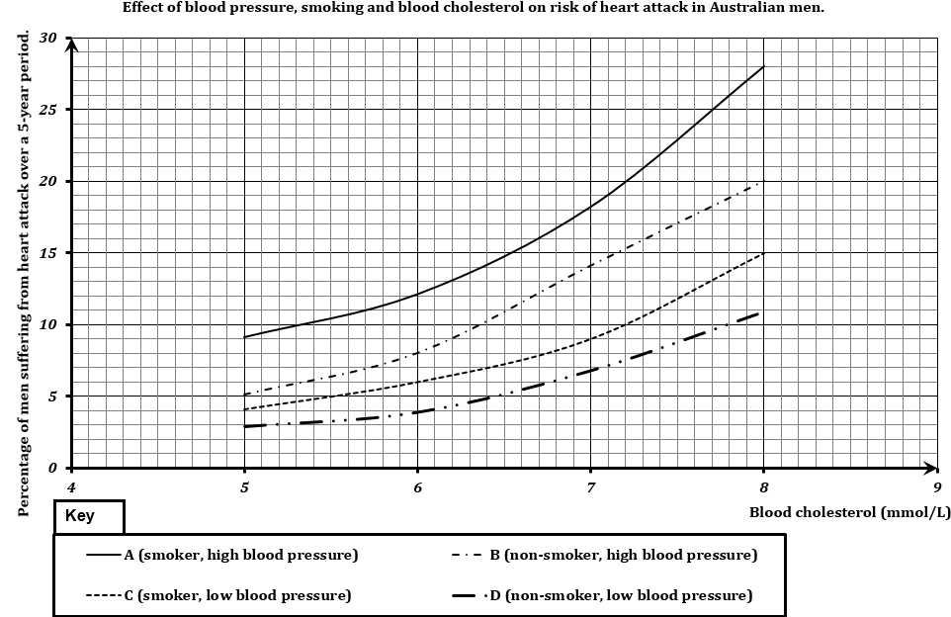

1. A smoker who has high blood pressure would like to reduce his risk of heart attack. If he could only change one risk factor, would he be better to give up smoking or to try reducing his blood pressure? With reference to your plotted graph, give a reason for your answer. (2 marks)

|  |  |
| --- | --- |
| **Description** | **Mark** |
| Reducing blood pressure | 1 |
| At any given cholesterol level, it will reduce the risk more than giving up smoking. | 1 |
| **Total** | **2** |

1. A non-smoker with high blood pressure has a blood cholesterol of 5 mmol/L. Over a period of three years, this concentration increases to 8 mmol/L. According to the graph, calculate how many times greater his risk of heart disease is. Show you working. (2 marks)

|  |  |
| --- | --- |
| **Description** | **Mark** |
| At 5 mmol/L, the risk is 5%. At 8 mmol/L, the risk has risen to 20% / risk 4 times more | 1 |
| The risks therefore 20/5 = 4 times more. | 1 |
| **Total** | **2** |

1. Two non-smoking men with low blood pressure both have a blood cholesterol level of 5 mmol/L. One of the men starts to smoke and the other man’s blood cholesterol level increases to 7 mmol/L. Which one of the two men is now at greater risk of suffering a heart attack? Explain your answer referring to data in the graph. (2 marks)

|  |  |
| --- | --- |
| **Description** | **Mark** |
| The one whose blood cholesterol level increases to 7 mmol/L. | 1 |
| The risk of the man who starts to smoke increases from 3% to 4%, ie. +1%  For the man whose blood cholesterol increases to 7 mmol/L, the risk has increased from 3% to 7%. ie. +4%. | 1 |
| **Total** | **2** |

1. Identify **two** components of diet that may contribute to an increase in the risk of heart disease. (2 marks)

|  |  |
| --- | --- |
| **Description** | **Mark** |
| Any two of the following for 1 mark each: |  |
| high levels of salt / large amounts of red meat / high levels of saturated fat / transfats / high sugar diets / high amounts of full cream dairy foods | 1 - 2 |
| **Total** | **2** |

**Question 33 (10 marks)**

The following questions refer to the diagram below showing a kidney nephron.

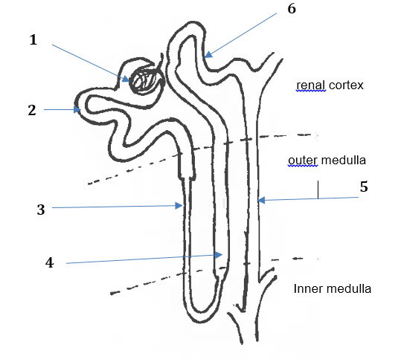

**Figure 8 Kidney nephron**

1. Match each of the processes (identified on the diagram with numbers 1 – 7) to the correct description of the process. Write the process number next to the correct description in the first column. Identify **one** substance passing through during this process in the last column where substances passing through are **not** given.

(8 marks)

|  |  |  |
| --- | --- | --- |
| **Process number** | **Description of the process** | **Substances passing through** |
| 1 | Filtration through the membranes of a glomerulus. | Glucose/ water / ions / urea |
| 3 | Reabsorption by osmosis in the descending limb of the loop of Henle. | water |
| 4 | Active transport of salt from the ascending limb of the loop of Henle. | sodium ions/ chloride ions |
| 6 | Active secretion of ions in the distal convoluted tubule | hydrogen ions/ potassium ions |
| 5 | Concentration of urine by osmotic withdrawal from the filtrate in the collecting duct | water |
| 1 mark for **correct** process number and 1 mark for a **correct** substance passing (need to be more specific than salt for 4 and ions for 6) | | |
| **Total** | | **8** |

1. Describe **one** feature of the proximal convoluted tubule that facilitates its function. (2 marks)

|  |  |
| --- | --- |
| **Description** | **Mark** |
| Any one of the following: |  |
| **Microvilli** to increase surface area to reabsorb substances from the filtrate. | 1 - 2 |
| The **in-foldings at the bases** give a large surface area to transfer reabsorbed substances into the blood capillaries. | 1 - 2 |
| A **high density of mitochondria** provide ATP for active transport. | 1 - 2 |
| (don’t accept **convoluted** )but ½ for increased surface area  **Total** | **2** |

**Question 34 (10 marks)**

1. To allow movement, the skeletal system consists of many bones held together at joints by flexible connective tissues and ligaments. Identify and describe the **three cl**asses of joint types. (6 marks)

|  |  |
| --- | --- |
| **Description** | **Mark** |
| Fibrous joints  the bones connected by fibrous tissues are tightly bound by connective tissues fibres (1/2)and there is no movement in such joints. (1/2) | 1 - 2 |
| Cartilaginous joints  the bone ends are connected by cartilage,(1/2) and this allows for limited movement.(1/2) | 1 - 2 |
| Synovial joints  the articulating bone ends are separated by a joint cavity containing lubricating synovial fluid, (1/2)and these allow for free movement in one or more planes (1/2). | 1 - 2 |
| **Total** | **6** |

1. Explain how antagonistic muscles work differently from synergistic muscles. (2 marks)

|  |  |
| --- | --- |
| **Description** | **Mark** |
| Antagonistic muscles work in opposition to another group of muscles. | 1 |
| While synergistic muscles work together to perform a certain motion or action. | 1 |
| **Total** | **2** |

1. Bone is classified as a connective tissue. Connective tissues consist of cells separated from each other by large amounts of matrix. Complete the table below to show the structural difference between bone and cartilage on a cellular level. (2 marks)

|  |  |  |
| --- | --- | --- |
|  | ***Name of the microscopic structure*** | ***Description*** |
| Microscopic structure of compact bone | osteons/  Haversian systems | At the centre of each unit, is a central canal around which are concentric layer of bone matrix. |
| Microscopic structure of  cartilage | Chondroblasts / Chondrocytes embedded in chondrin | Collagen fibres are embedded in the matrix and within the matrix are spaces that contain cartilage cells. |
| 1 mark for each named structure | | |
| **Total** | | **2** |

**Section Three: Extended answer 20% (30 Marks)**

**Question 40 (15 marks)**

Around 1 in 100 Australians have coeliac disease which is an autoimmune disorder where the immune system, mistakenly produces antibodies which attack and damage its own tissues. In the case of coeliac disease, it is triggered by gluten which is a protein found in wheat, oats, rye and barley. When a person with coeliac disease consumes gluten, through normal digestion, the gluten comes into contact with the small intestine walls. This brings about an auto-immune reaction which causes inflammation and eventually the intestinal villi becomes destroyed. If left untreated, this condition can lead to liver disease, infertility, osteoporosis and cancer.

1. State **two** reasons why a person suffering from coeliac disease will experience a combination of the following symptoms – abdominal swelling and flatulence, diarrhoea, cramping, nausea and vomiting, and weight loss. (2 marks)

|  |  |
| --- | --- |
| **Description** | **Mark** |
| Reasons |  |
| Once the intestinal villi become atrophied (shrink), there is **less surface area for nutrients** from the diet to be absorbed into the blood stream. | 1 - 2 |
| People with coeliac disease suffer from **inefficient absorption (malabsorption**) so the symptoms of fatigue sets in due to malnutrition and vitamin deficiencies. |  |

1. Outline how **four** of these symptoms arise in a person suffering from coeliac disease. (4 marks)

|  |  |
| --- | --- |
| **Description** | **Mark** |
| How the symptoms arise |  |
| Abdominal swelling and flatulence due to the **body’s inability to digest the food** and excessive bacterial breakdown of food causes increase production of gas, causing abdominal bloating. |  |
| Cramping due to the **overproduction of gas, diarrhoea and abnormal gut movements/spasms.** |
| Nausea and vomiting us related to the **large amount of undigested food in the small intestine and the stomach**. Abnormal gut movements may also cause vomiting. | 1 - 4 |
| Weight loss is to the **poor digestion and reduced absorption of food**. The body does not receive the nutrients it needs to maintain daily activity. It starts **metabolising stored fats** and even proteins, resulting in weight loss. |

1. Compare and contrast between osteoporosis and osteoarthritis (6 marks)

|  |  |
| --- | --- |
| **Description** | **Mark** |
| Similarity: | 1 2 |
| Both pertain to bone degenerative conditions.  Both may be attributed to ageing. |
| Differences | 1 - 4 |
| **Osteoporosis** – loss of bone mass/ reduction in the amount of bone/ bone become porous/ bones are fragile/ and /or easily fractured or broken |
| **Osteoarthritis** – degeneration of a joint/ degeneration of articular cartilage at a joint/ causes development of bony spurs/ restricts movement / causes pain |
|  |  |
|  |  |
| **Total** | **6** |

1. . Explain why coeliac disease could lead to osteoporosis but not osteoarthritis. (3 marks)

|  |  |
| --- | --- |
| Any three of: |  |
| Reduces calcium uptake  Requires body to remove calcium from osteons/ bones  Bone density decreases  Does not affect cartilage/the joints | 1 - 3 |

**Question 41 (15 marks)**

1. There are different types of proteins that are found in various combinations in the living systems, from single-celled to multi-cellular organisms. In humans, there are three types of proteins often associated with the circulatory system, the digestive system and the muscular system.

Discuss the importance of transport proteins, enzyme proteins and contractile proteins associated with three body systems stated above. (10 marks)

|  |  |
| --- | --- |
| **Description** | **Marks** |
| **Transport proteins** - **Circulatory System** | 1 - 3  1 - 3  1 - 4 |
| These proteins pass ions and vital molecules such as glucose and amino acids across cell membranes. |
| Haemoglobin, found within red blood cells,  - transports oxygen from the lungs to different parts of the body. (circulatory system) |
| **Enzyme proteins** – **Digestive System** eg. salivary amylase, lactase, trypsin, lipase etc. |
| Biological catalysts that mediate biochemical reactions that occur within a cell. |
| Digestive enzymes eg. amylases, proteases and lipases break down starch, proteins and lipids. |
| These starch, proteins and lipids are broken to simple forms (glucose, amino-acids and fatty acids & glycerol) respectively so these can diffuse into cells. (digestive system) |
| **Contractile proteins** – **Muscular System**  eg. actin and myosin |
| These proteins **can change shape rapidly**. |
| Actin & myosin are the proteins in muscle tissue that enable the human body **to move their limbs**. |
| These proteins are found on the myofilaments which are bundled as myofibrils contained in the bundle of muscle fibres. |
| The **ability of the muscle to contract** is due to the action of actin and myosin protein molecules sliding over one another.  (muscular system) |
| **Total** | **10** |

1. Compare and contrast the processes of aerobic and anaerobic respiration in terms of the quantity of energy released, the reactions involved and the location of chemical reactions within the cell. (5 marks)

|  |  |
| --- | --- |
| **Description** | **Marks** |
| Similarities | 1 - 2 |
| Both are part of cellular respiration, one of the most important metabolic processes in any cell. |
| Both involve the breakdown of glucose to provide energy for cellular reactions. |
| Differences |  |
| The quantity of energy released: | 1  1  1 |
| Aerobic respiration – one glucose molecule can release enough energy to form up to 38 ATP molecules from ADP |
| Anaerobic – one molecule of glucose can release enough energy to form two ATP molecules from ADP. |
| The reactions involved: |
| Aerobic respiration requires oxygen and involves a series of reactions: glycolysis, the Krebs cycle and the electron transport system. |
| Anaerobic respiration requires no oxygen and involves only glycolysis, and then the conversion of pyruvic acid to lactic acid. |
| The location of the chemical reactions within the cell: |
| Aerobic respiration occurs in the mitochondria of the cell. |
| Anaerobic reaction occurs in the cytoplasm of the cell. |
| **Total** | **5** |

**Question 42 (15 marks)**

There are a number of specific factors and/or lifestyle choices that increase the probability of someone suffering from lung disease. In this context, `lung disease’ refers to chronic obstructive pulmonary disease (COPD), which includes emphysema and chronic bronchitis.

1. State **four** factors and/or lifestyle choices associated with lung diseases. (4 marks)

|  |  |
| --- | --- |
| **Description** | **Marks** |
| Any four of: |  |
| **Smoking** – inhaling of irritants of smoke/ cigarettes/ tobacco/ cigars/ exposure to toxins from cigarettes/ tobacco/ smoke | 1 - 4 |
| **Air pollution** – particles and/or gases (sulphur dioxide/ nitrogen dioxide/ carbon monoxide in the air |
| **Genetics** – Some people are genetically more prone to get lung disease; others less, which explains why some lifelong smokers never get lung disease while others die early. |
| **Infections** – people who frequently get other chest infections also show a higher incidence of lung disease. |
| **Occupation** – people working with harmful chemicals, gases and dusts that can be inhaled have an increased risk of lung disease. |
| **Total** | 4 |

1. In a healthy individual, describe how the structure of the alveoli contributes to the efficiency of gas exchange. (5 marks)

|  |  |
| --- | --- |
| **Description** | **Marks** |
| Any six of: |  |
| Alveoli surfaces are moist and thin allowing for faster diffusion. | 1 - 5 |
| Large number of alveoli in each lung (about 300 million). |
| Each alveolus is highly vascularised/covered by a dense network of pulmonary blood capillaries. |
| Each pulmonary capillary surrounding the alveolus has a single layer of epithelial cells |
| Alveoli and blood capillaries have a very large surface area. |
| Blood flow through the pulmonary capillaries surrounding each alveolus maintains a concentration gradient/ allowing rapid diffusion/ Red blood cells are slowed as they pass through pulmonary capillaries, allowing time for diffusion |
| **Total** | **5** |

1. In the case of an individual with COPD, one characteristic symptom of the disease is shortness of breath. Compare the effects of emphysema and chronic bronchitis and suggest how and why breathlessness arises in each case. (6 marks)

|  |  |
| --- | --- |
| **Description** | **Marks** |
| Any three of: | 1 – 3  1 - 3 |
| **Emphysema** is a disease caused by long-term exposure to irritating particles in the air taken into the lungs. |
| As a result, **alveoli are damaged, elasticity is lost and alveolar walls are broken down.** |
| This reduces the internal surface area of the lung. |
| Due to loss of elasticity, t**he lungs are constantly inflated, and breathing no longer occurs passively but requires voluntary effort.** |
| Breathlessness result due to insufficient surface area for gas exchange and difficulty in ventilating the lungs. |
| Any three of: |
| **Chronic bronchitis** is caused by **persistent infections/viral infections**/**breathing in air pollutants,** fumes or dust over prolonged period of time may also cause this. |
| This results in the **inflammation of the bronchi.** |
| These inflamed bronchial tubes produce **a lot of mucus**.  This leads to **coughing and difficulty in breathing**. |
| **Total** | **6** |

THE END